Bel Nix: Tactics

Team G: The Fighting Mongooses

*Connor Richards*: Systems Design, Production

*Jena Ruhl*: In-Game Art

*Justin Saletta*: Engine Programming

*Jonathan Steven*: UI Art, Systems Programming

*Ryan Torres*: Audio, Systems Design, Creative Lead

Not enrolled in ICS 169A

*Alicia Keech*: Concept Art

*Andrew Torres*: Systems Design, Additional Programming

# What is Bel Nix?

Bel Nix is a table-top campaign using a custom creation of the Dungeon and Dragons rule-set.

Bel Nix: Tactics is a video-game adaptation of this table-top campaign, focusing on the turn-based tactics combat. It is a top-down, turn-based, squad mechanic game that focuses on the strategic manipulation of your units and the utilization of the classes’ unique features.

Bel Nix is unique from typical D&D campaigns in that it utilizes a two-pronged health system. Every unit contains Health Points and will fall unconscious if it reaches zero, as well as they contain Composure Points and will instead fall into a primal state based on their race if it reaches zero. Along with HP and CP, Bel Nix slims down on unnecessary build choices and only contains meaningful and justified decisions for the type of character you want to create and play. This is supported by our five classes, each with unique utility and functionality.

# Scope and Goals

During this first 10 week quarter, we really want to nail down the combat system and make sure it is fun and exciting. Being a tactics videogame we need to make sure that the main player experience, fighting in battles using turn-based combat, is responsive and has each class feeling fresh and unique. All of the design and balance has been tested with our extensive table-top campaign, and all that remains is transferring what we have into the virtual game. To accomplish this, the essentials include the ability to create tile maps, create characters, navigate the maps, and select actions that function properly. We have a preliminary tile-editor and character creation already functioning, so we are on-track to have our combat system done by the end of the first quarter, if not sooner.

If enough time is still available after taking into account polish for the combat system, then we will use the second 10 week quarter to implement the mission system. This will utilize objectives, free-roaming the created maps, and some text-based conversation. We already have a small text-editor in the works to fulfill that need, but more time and focus will go into the rest of the mission system when we are sure it is an accomplishable task.

Our final stretch goal would be to implement a stealth system to complement the missions as an alternative to talking or fighting your way out of situations. We expect to focus most of our time on polishing the previously mentioned milestones, but if we are way ahead of schedule, then stealth would be our next focus.

# Systems and Software

We are utilizing the Unity game engine, and we are coding in C#.

Justin has already created our own tile-editor tool that takes in the maps we create and gives us the ability to alter the attributes of the tiles to allow for functions such as standing, triggers, actions, and difficulty of being passable from any direction. The following screenshot depicts an example map after having the tiles appropriately set:

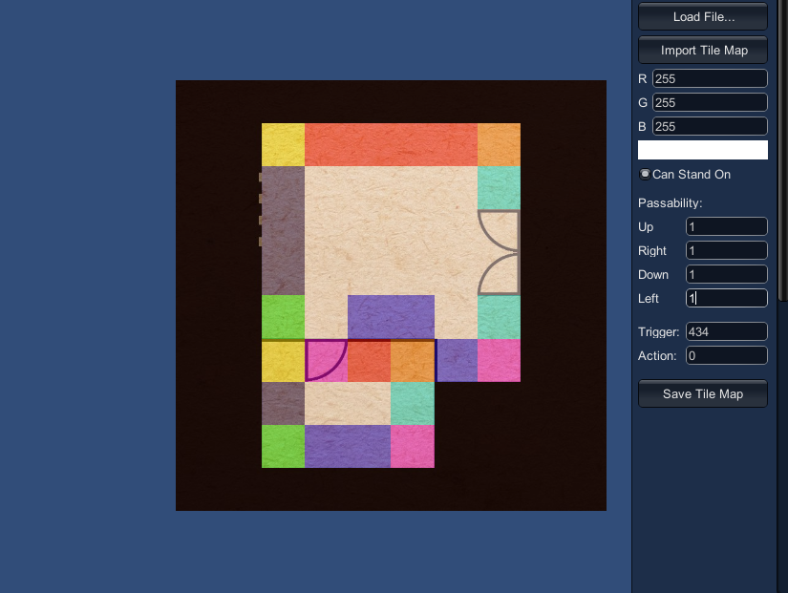

We also have our character sheet and character creation programmed thanks to Jonathan, and we just need to finish up the full implementation. Featured here is how the dependencies work on the character sheet:

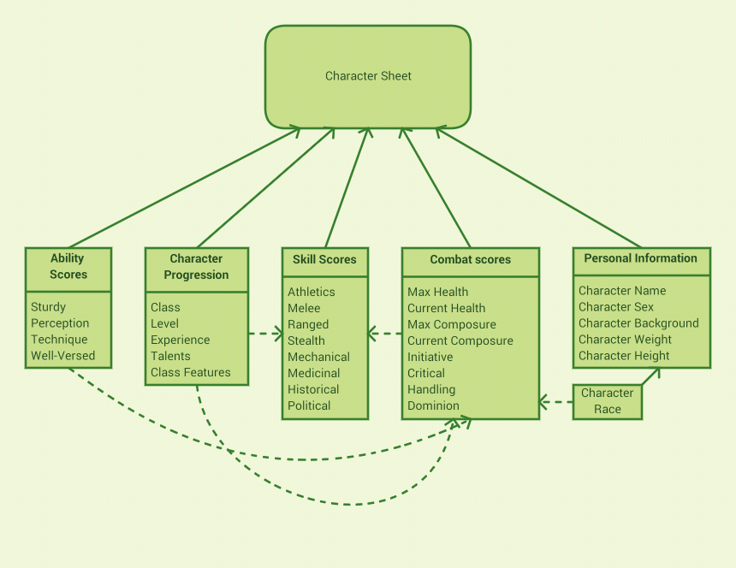

# Core Experience and Gameplay

Experience:

*Survival:*

Raw aspects of survival: darker human condition: Crime

Dungeons and Dragons was a huge part of my social gaming life in college. Our friends would get together and play every week to save kingdoms and traverse an epic story. Many of the players, including myself, found it difficult to role-play as a criminal or someone of an evil alignment. While most of us tried to write up a character with the intention of being a villain, the pressures of being a hero were too great. One week, after finishing a year-long campaign, I declared I would develop a new campaign dedicated to making each of the players a criminal. Bel Nix began as a table-top GURPS game played among friends that was meant to be a campaign for players to be as unabashedly evil as they wished. There were several story aspects that were written in to accomplish this task. While playing through the campaign, however, we found that the extreme difficulty and permanent death was more than enough to convince players of committing crimes out of sheer desperation. Through Bel Nix: Tactics, we hope to recreate this desperation and explore the darker aspects of the human condition abreast with survival.

Unlike most rogue-likes, where only progress through the game is lost, death in table-top gaming comes at the price of losing your character. Some table-top gamers take it so far as to rip up the character sheet as that character is truly dead to them. As with most RPG's, a core drawing experience is the desire to see their own character flourish and grow. Players who have played table-tops, such as Dungeons and Dragons, will know the careful planning and decision making while crawling through a dungeon to keep your high level character alive. Adversely, they too know the deep cut of losing such a character they have invested so much time into and have become attached to. It is this fear of loss, not unlike the fear of our own mortality that drives such careful planning and raw determination to survive.

It is these experiences of personal growth and survival that table top gaming have given us that we wish to bring to the player through Bel Nix: Tactics.

Core Gameplay Pillars:

The survival experience we aim to deliver will rely on mechanics that require careful decision making in order to ensure your team's survival. As the team's leader, it is the player's job to weigh each decision both in and around combat. Our engagements will center more on giving the player enough information to make an informed decision, rather than encouraging trial and error tact. Similar to the rogue-likes such as FTL, unit death is permanent and we will use this permanence to give these decisions the gravitas they may not find in other games with quick save functions. While many of these decisions will be made in the midst of combat, we want to include additional elements of conversation and stealth as non-violent alternatives allowing the player to choose to avoid conflict. Our main efforts will be in delivering a truly turn-based tactical experience with the hopes of adding these other elements later to give the game more variety and flavor.

*Tactical Combat:*

Physically confronting enemies and challenges head-on will be where the player spends most of their play time. Not unlike FFTA and Fire Emblem, Bel Nix will focus on unit coordination and class synergy. Taking control of the full team, the battlefield will act more as a puzzle than a place of combat as the player determines how to make the most of the classes' features to exploit the enemies’ weaknesses in both stature and tactical position.

Bel Nix's turn by turn combat works on an initiative based system. Units roll a die and add certain stats to determine their "initiative". These initiatives are then ordered from largest to the smallest. The unit with the largest initiative takes their turn first, then the unit with next largest initiative, and so on. For the sake of convenience, we store this order in a list called a turn order, or a round. When the last player in the round takes their turn, the round is reset back to the unit with that largest initiative.

During a unit's turn, the unit can take up to four actions in total. These actions are broken into the following: one Movement Action, one Standard Actions, and two Minor Actions. Once all of these actions have been used or passed, the unit's turn is over and the next unit in the round can take their turn. Breaking up the turn into four actions allows easier action management as the actions are discretely packaged and fairly independent from the unit's other actions in that turn.

The movement action deals with any physical movement of the unit's token, such as running, jumping, falling and navigating the terrain. Movement is an important aspect of combat and how a player's units are positioned can be the difference between survival and death. Standard actions are large actions, such as attacking an enemy or using a class feature. These actions are generally geared toward interacting with other units on the field. Minor actions, on the other hand, are smaller actions like talking, drawing a weapon, or dropping an object to the ground. Minor actions are much quicker than movement or standard actions, and as such each unit is allowed two per turn. Since moving, attacking, and using abilities are the main way units interact with each other they are limited in order to maintain balanced game play.

# Preliminary Art

Top down character alpha in 64x64 pixel tiles (utilizing extensions during certain attack frames):

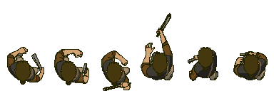

Very small portion of the large number of maps created for the table-top version of Bel Nix, soon to be converted for use in the Tactics game:

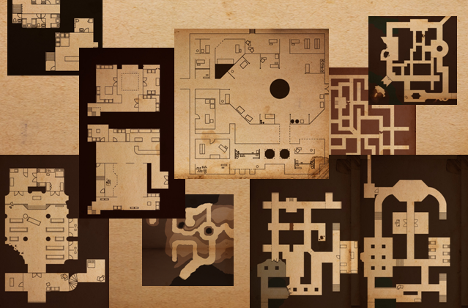

First draft of ‘Jackie’ concept art from Jena:

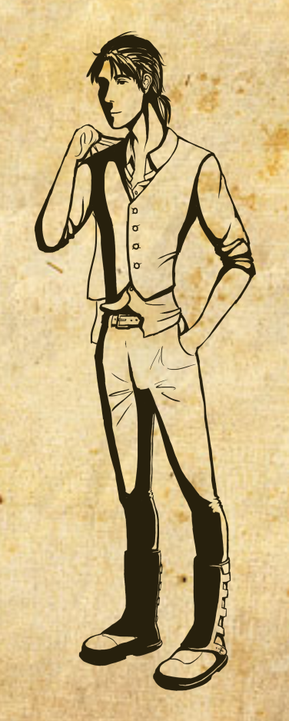

# Inspiration

Final Fantasy Tactics

X-COM: Enemy Unknown

Various D&D Campaigns